**Box Generator**

Create a component with a form inside which accepts a color. When the form is submitted, add a box to the set of boxes with the appropriate color. You may use whichever method of styling you prefer; refer back to the end of the previous module (React Components) for more information on styling. The boxes should appear next to one another and wrap around if needed.

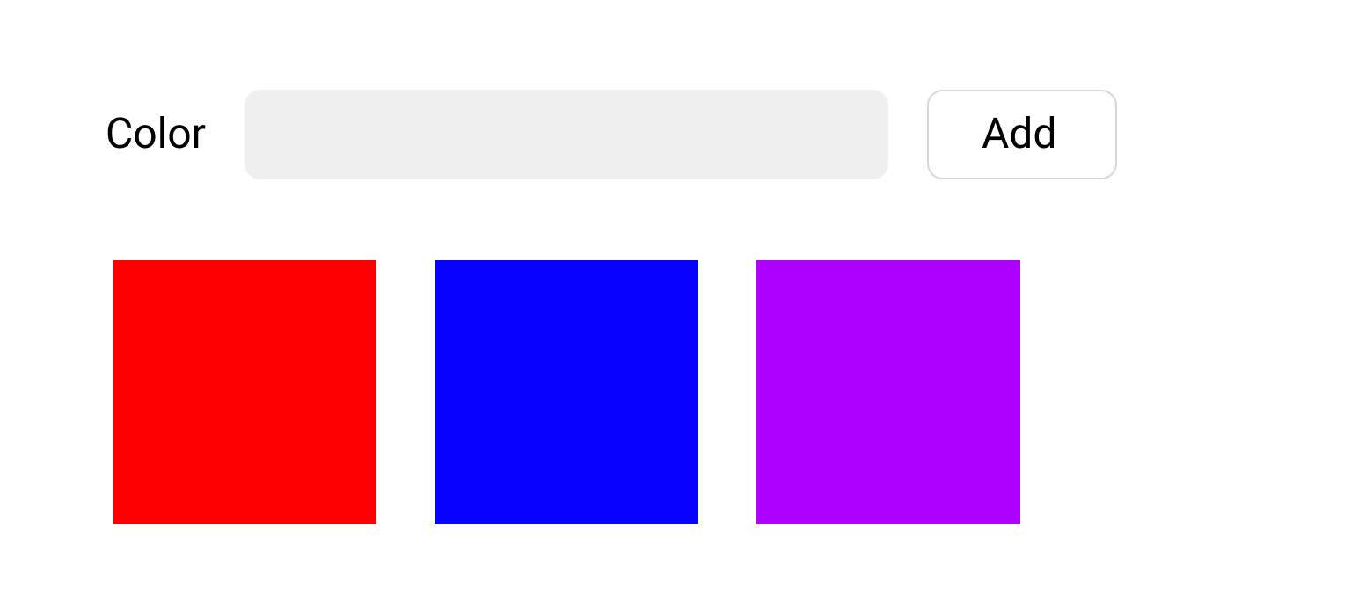

* Top of Form
  + Allow the user to create/add boxes of various colors.
  + On successfully adding a new box, have it appear in the set immediately.
  + Ninja Bonus: clear out the color input on successful submission.
  + Ninja Bonus: Add a second input that takes in an integer. This integer will allow the user to specify the height and width of the generated box.

Bottom of Form